As a prerequisite you need to have a python executor on your PC, the easiest way would be to install spyder. https://www.spyder-ide.org



To use this program, you must first go to the file on github and then you will find the path here.

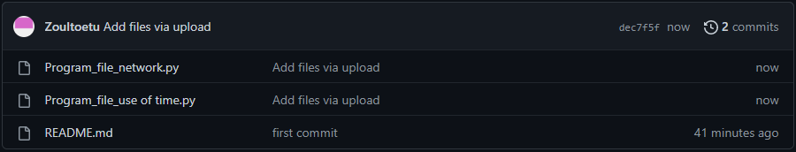

You have to download it then launch it in spyder then as soon as the program is displayed you have to press F5 or launch the program with the small arrow start.

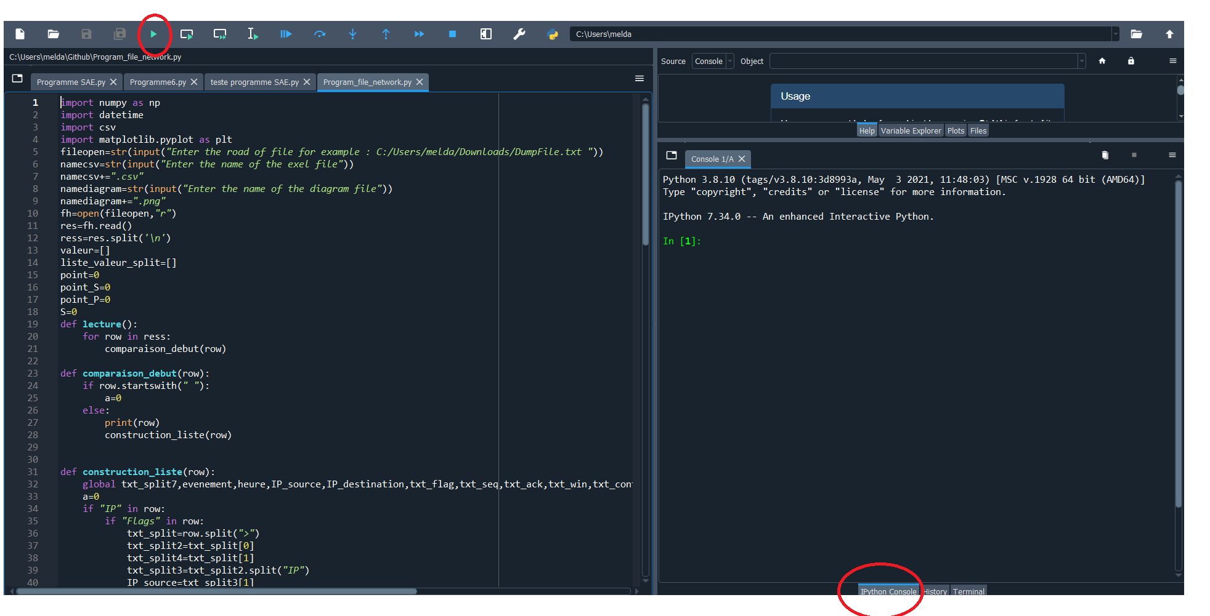

then check that it is the python console that is launched.

Now we are going to ask you to first enter the address of the file you want to sort.

Then the name of your exel file and the diagram.

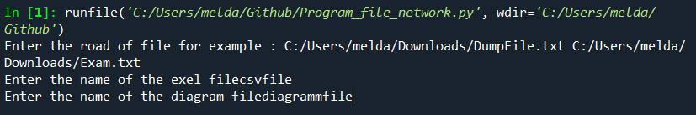

Then in your download directory you will find your exel file and the diagram in the same place as the python file.

